BRUTEFORCE ATTACK- USERNAME ENUMERATION

1. NETWORK REQUEST OF THE ATTEMPTED LOGIN- POST REQUEST

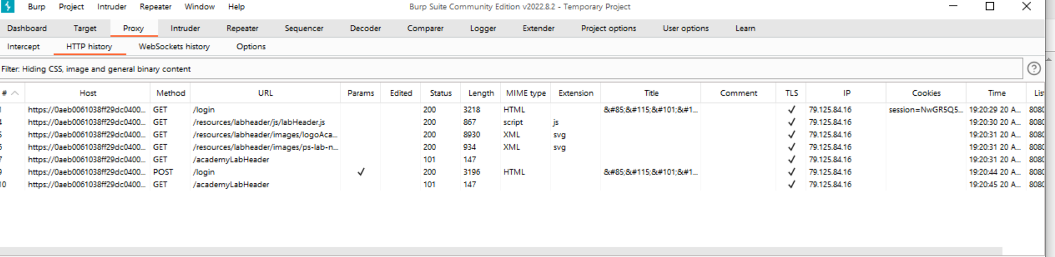

1. POST REQUEST- REQUEST AND LOGIN

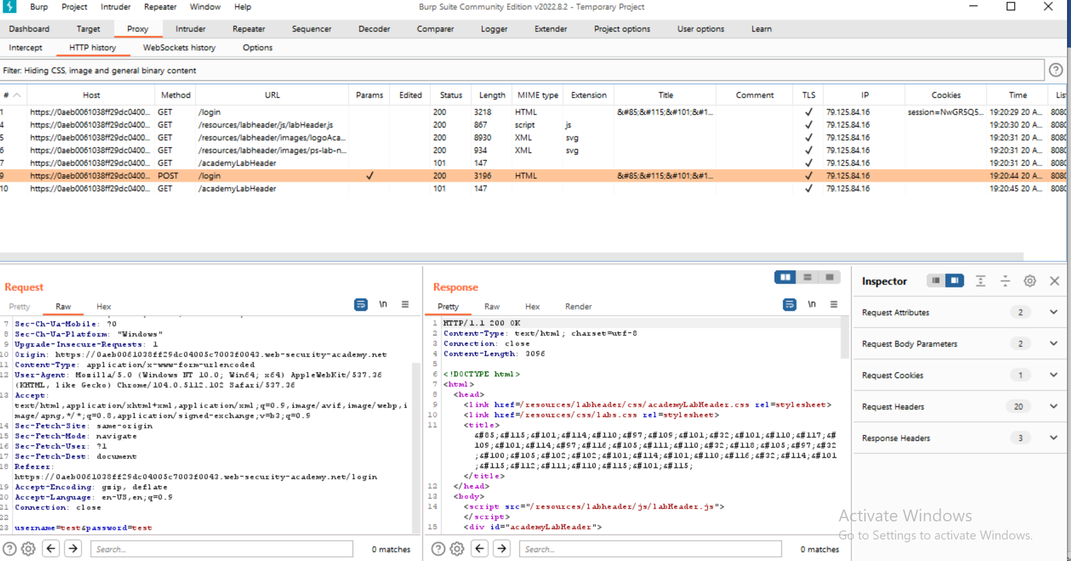

3. PAYLOADING THE USERNAME AT THE INTRUDER

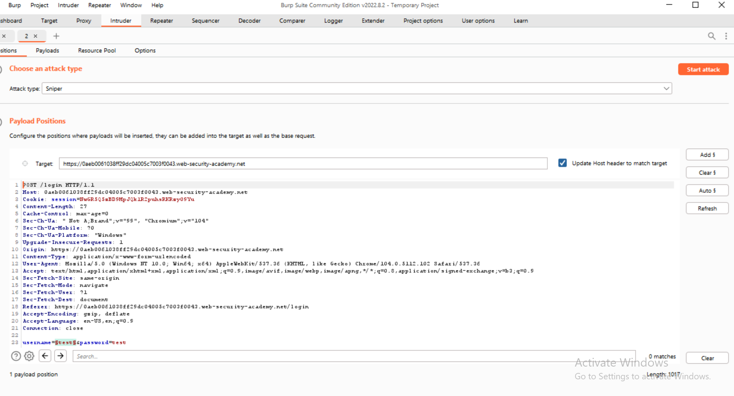

4. USERNAME RESULT ai- 3198

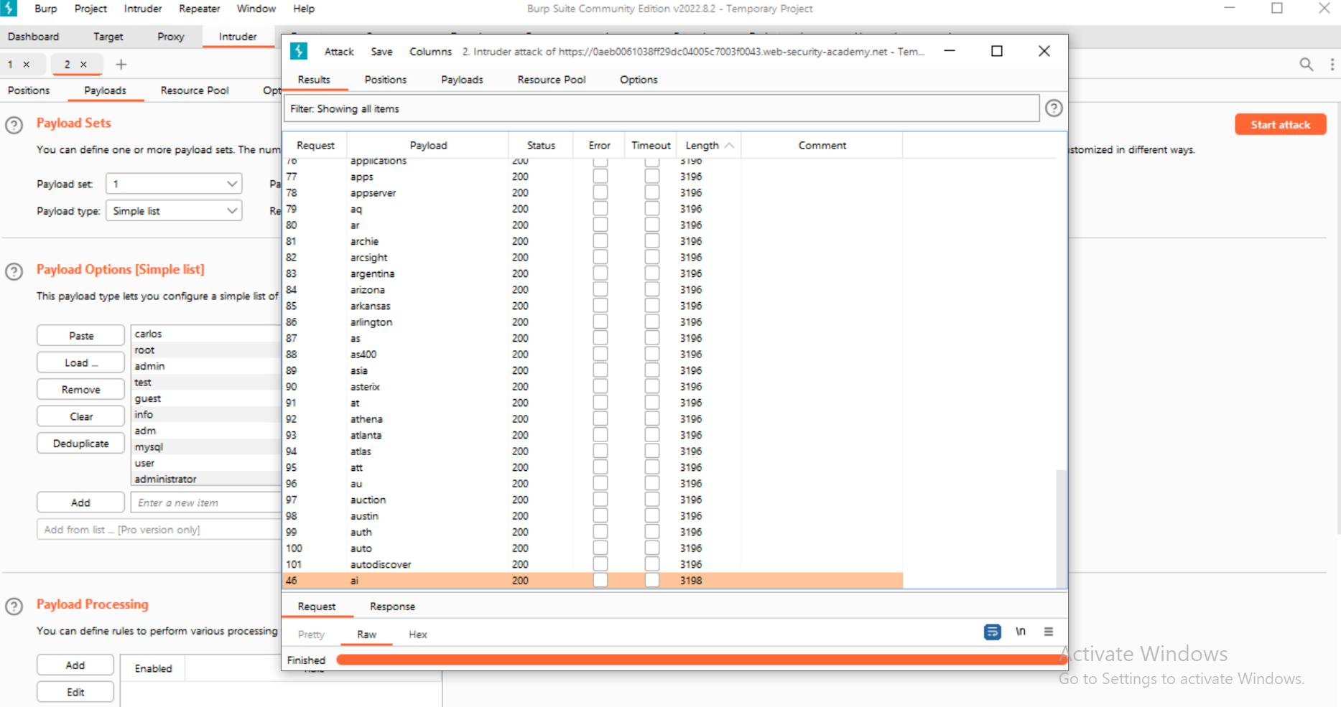

5. PASSWORD- 123456 , STATUS-302, LENGTH -170

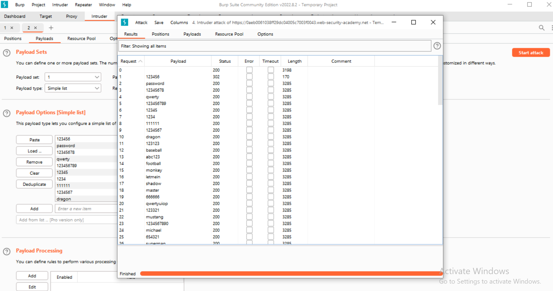

6.

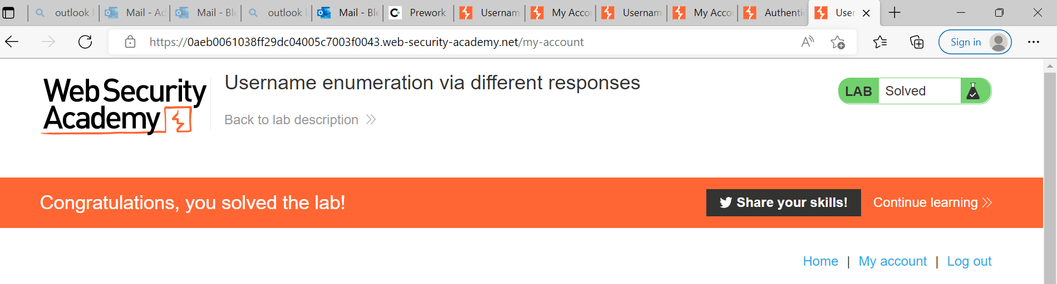

7.

HALL OF FAME ENTRY

